Project: 1

Name of the project: SMS Sender App using android studio.

Introduction:In Android, we can use SmsManager API or devices Built-in SMS application to send SMS's. Through this app we easily communicate to each other by sending SMS.

Motivation:To increase communication skills of others I think I will design an app that communicates to others. For these reasons I developed this app.

Description: We will use Android Studio IDE to create the SMS sender and name it under a package com.example.sms. Modify src/MainActivity.java file and add required code to take care of sending sms. No need to define default string constants at res/values/strings.xml. Android studio takes care of default constants.

Some snaps: 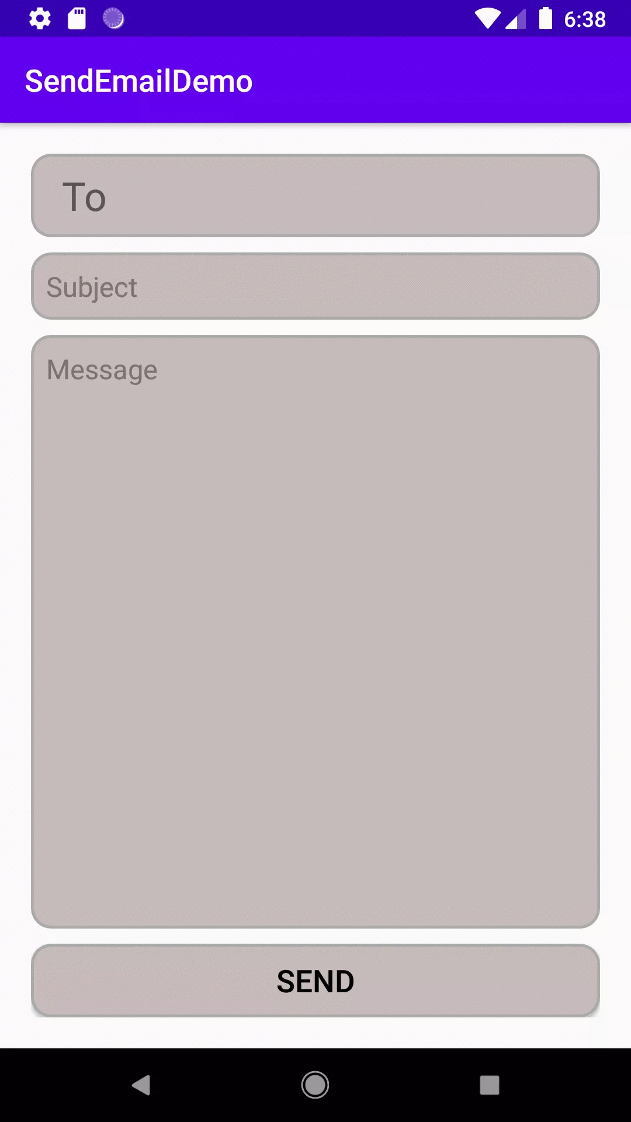

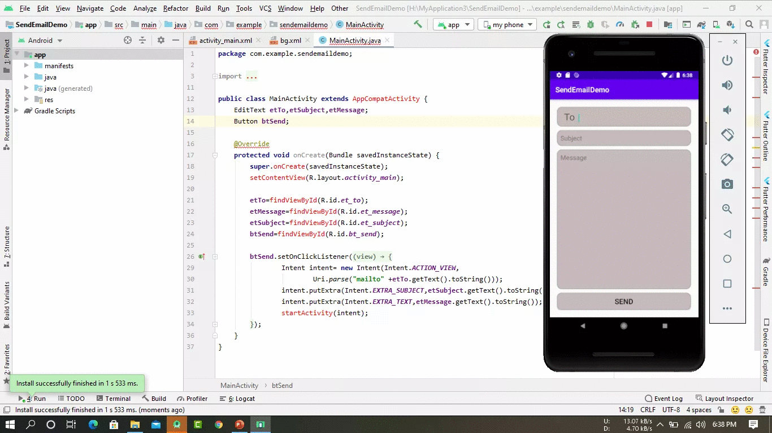

Project: 2

Name of the project: Comilla University Mobile App using android studio.

Introduction:In Android, we can use manager API or devices Built-in CoU application to find Comilla University all information. Through this app we easily know all our University information.

Motivation: In this era ,we all need to find information in a shortcut way. For university students we also need to know our institute information such as admission ,examination date,exam result, reports, and so on. So ,for this reason I think I will develop an android app.

Some Snap: